 | BNM Institute of Technology  An Autonomous Institution under VTU. Approved by AICTE  SECOND YEAR STUDENT’S IPL PROJECTS  Title: AIML-BASED SOLUTION FOR DETECTION OF FACE SWAP BASED DEEP FAKE IMAGES.
ABSTRACT & INTRODUCTION  1. Deepfakes threaten the authenticity of digital media.  2. This study proposes using CNNs to detect face-swapped deepfake images.  3. Identifies subtle inconsistencies in facial features and textures.  4. The CNN model offers a scalable solution for accurate deepfake image detection.  5. This work provides a reliable method to combat face-swapped deepfakes. |  | BLOCK DIAGRAM | HW/SW REQUIREMENTS
 |  | 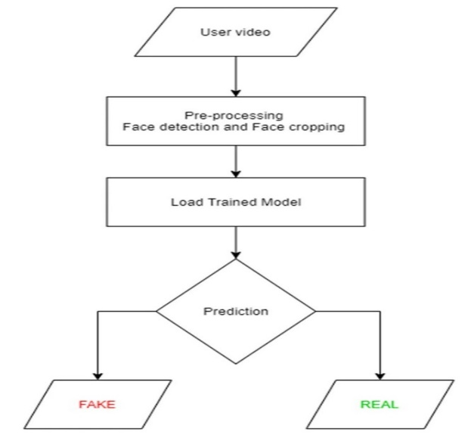  Figure 1. Block Diagram | - CNN detects face-swapped deepfakes effectively.  - Works for large datasets and real-time use.  - Performance may vary with high-quality deepfakes.  - Improve detection for diverse manipulations.  - Strengthens digital media security.  Hardware: GPU, multi-core CPU, 16 GB RAM, 500 GB SSD.  Software: Python, TensorFlow/PyTorch, OpenCV, Anaconda.  .
 |  |  | CONCLUSION
OBJECTIVE |  | COMPLETE ASSEMBLY PICTURE | CONTRIBUTORS
- Design an AIML-based solution for detecting face-swap deep fake images.  - Utilize CNNs to identify inconsistencies in facial features, textures, and lighting.  - Enhance digital media authenticity and trustworthiness.  - Provide a scalable and robust detection framework.  - Ensure high accuracy and reliability in identifying manipulated images |  | 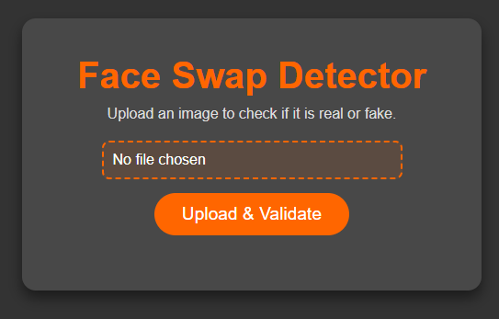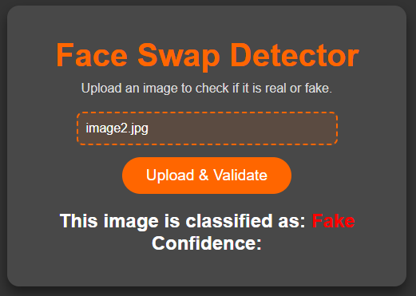 | Mentor Details :  Dr. Deepak D J  Associate Professor  Department of CSE  Students Details :  Apeksha G S: 1BG23CS016  Kruthi K Shetty: 1BG23CS063  Brunda S: 11BN24CS416-T

